**Curriculum Vitae of Cameron Jordan Sheosunker**



**Details**

I.D Number : 0005175122083

Nationality : South African

Race : Indian

Sex : Male

Marital Status : Single

Driver’s License : Code 8

Address : 19 Second Street Hillary, Durban, 4094

Contact Number : 071 873 3907

Email Address : cameronjsheosunker17@gmail.com

**About Me**

I am a B.Sc. in Information Technology Graduate.

I have recently completed my studies at North West University and will receive my official degree in June this year. I am very grateful that I was given the opportunity and also very honoured to have passed my degree with distinction. My university experience has been challenging, I have gained a lot of knowledge during these past three years and have had my fair share of ups and downs.

I am a quick and focused learner who can absorb new ideas and can communicate clearly and effectively. I also possess good bonding skills and have an inquiring mind that is eager to broaden my knowledge in the industry. I have a fascination with building websites, database management systems and general applications. I also strive for a high degree in accuracy and attention to detail.   
  
My current interests are in video games, I absolutely love modifying games, currently trying to create some of my own mods. I find artificial intelligence fascinating and the idea of allowing machines to "think for themselves". I also enjoy computer assembly, even though some of the prices for components are way beyond my budget.

I am currently trying to broaden my understanding on Cloud Computing and Artificial Intelligence with various online courses including Amazon (AWS) and Google as well as DevOps.  
  
I also like fishing, because even if I don't catch anything, its' still very relaxing and peaceful if no one steals my fishing spot. Finally, I enjoy socializing & traveling, I am always eager to make new friendships along the way. Overall, I am passionate about technology. I would love to be given the opportunity to learn more about it.

**Work History**

### Administrator Clerk, CLS Brokers; 2018 - 2020

CLS Insurance Brokers is a family owned business where I worked as an administrator, handling client queries, quotations and filing. I have learnt many skills throughout my employment such as good communication and listening skills, reporting and problem-solving.   
For a project for one of my modules, I had to create a database management system for a business. I decided to use CLS Brokers as inspiration for the project. This system was written in C# Visual Studio.

**Education**

1. **Kharwastan Secondary School**

Subjects:

* English
* Afrikaans
* Life Orientation
* Mathematics
* Physical Science
* Information Technology
* Geography

Duration: 2012 - 2017

1. **North West University**

Qualification**:** B.Sc. IT

Duration: 2018 – 2020

**Skills**

Hardware:

Maintenance, Peripherals, Printers, Drivers and Troubleshooting

Software:

* Microsoft Office (Excel, Word, PowerPoint, Projects and Access)
* Visual Studio
* Visual Studio Code
* QM for Windows
* Linux
* Programming Languages:
* Python
* C#
* C++
* C
* JAVA
* VB.NET
* ASP.NET MVC
* HTML, CSS & JavaScript
* SQL

**Achievements**

* Created a CV/Resume Website using HTML, CSS and JavaScript.
* Created a website with a database management system in asp.net MVC Core.
* Created a digital solution for a theoretical business, going fully in depth with the system development life cycle, including project documentation.

**Official Statement from North West University**

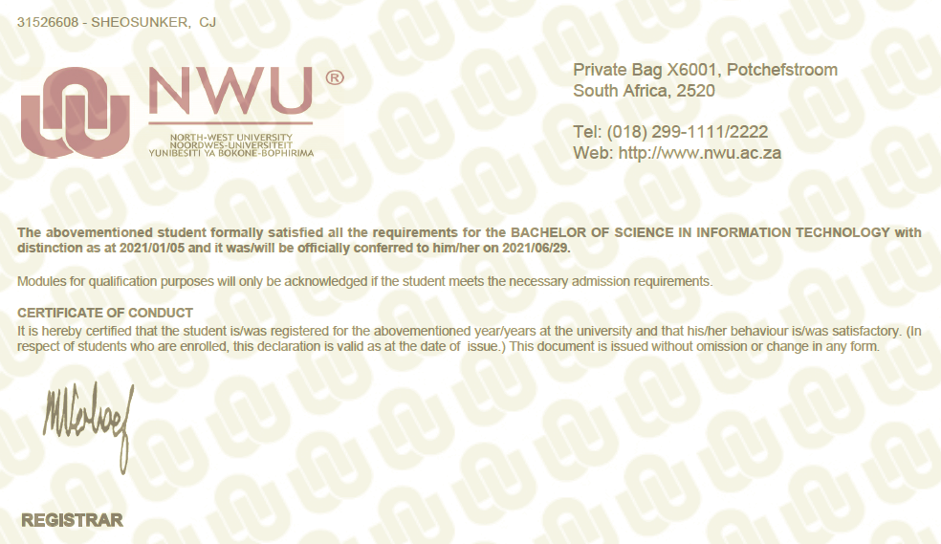

Thank you for taking the time to review this document. I hope to hear from you soon.